Instructor Portal Guide
AIM
Accessible Information Management
7/1/25


  - Disabled Students Programs and Services

WHAT IS THE INSTRUCTOR PORTAL?
The Instructor Portal is designed for instructors and faculty to manage student accommodations. Through this portal, instructors can:
- View and read accommodation letters across all courses in one location.
- Complete the Testing Agreement for accommodated exams.
- See all exam requests submitted by students.
- View a list of textbooks being converted into accessible formats.
- See assigned interpreters for students.
- Identify assigned notetakers and review uploaded notes.

INSTRUCTOR PORTAL: WHAT FACULTY SEE 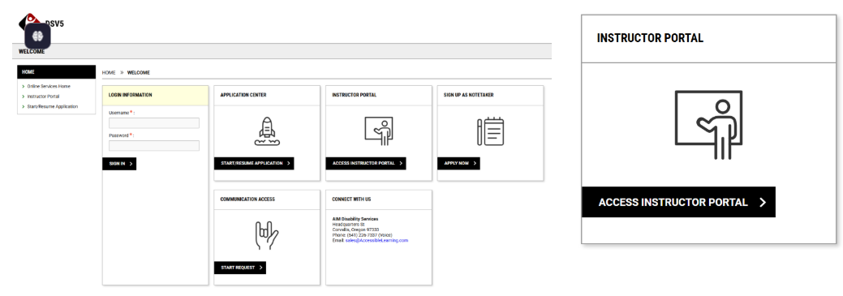
Instructor Experience
- Click the link to the Instructor Portal through the disability services website or a direct link in the faculty notification letter
  - The disability services office must provide a login link formatted as: http://nameofserver.accessiblelearning.com/yourschool/instructor
- Access the Instructor Overview Page, where instructors can:
  - See all students with accommodations
  - View the main accommodations requested
  - Check whether they have read the faculty notification letter (Only updates if read through Instructor Access, not via email)

OVERVIEW
Defaults to current term and list of requested accommodations. The Home Menu on the left will always be displayed.
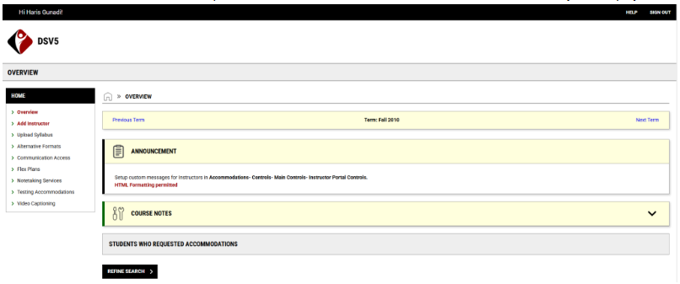

Announcement
General announcements for instructors created by the DS staff will display when available.
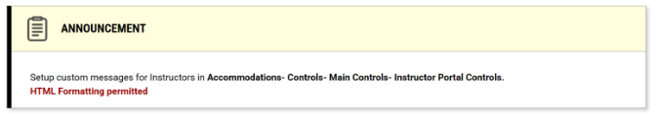

Course Notes
If a course has specific notes that apply only to it, they will display here. Not all courses will have these. 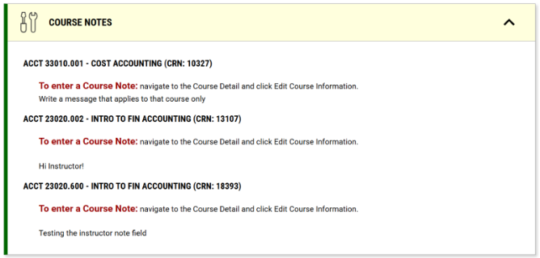

Students Who Requested Accommodations
Instructors see the overview of all their students, the main accommodations they requested, and if the instructor has read their faculty notification letter (only counts if faculty read the letter through instructor access. Does not work if faculty reads the letter via email). Instructor can click view next to a specific student’s name to see the letter.
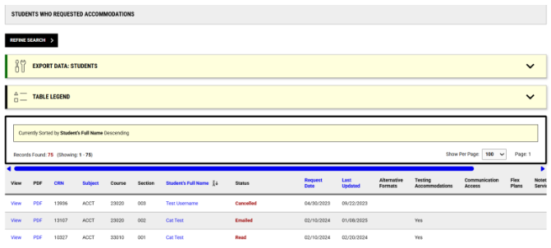

Optional: Acknowledge All Accommodations
Instructors can use the Handy Tool to acknowledge all accommodations requested. 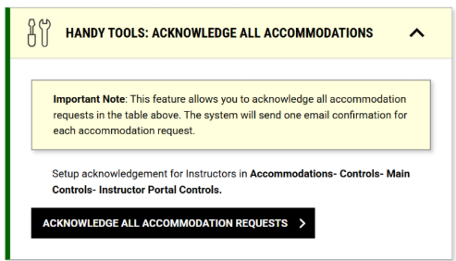

Optional: Students Who Have Not Requested
Primarily used by institutions promoting Universal Design, a section at the bottom of the overview page will list students registered with disability services who have not requested accommodations.

Eligibility Search
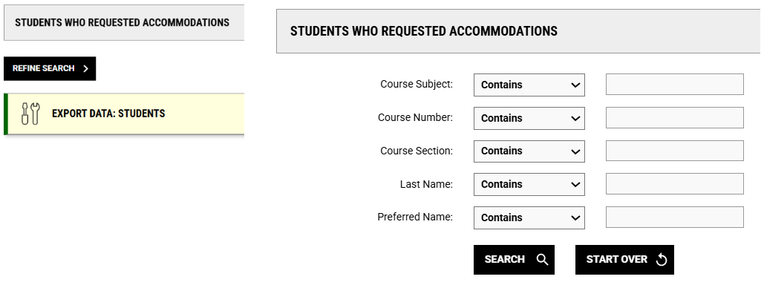
- In the Students Who Requested Accommodations, select Refine Search.
- The Search Options will display. Search by Subject, Course Number, Section, Student Last or Preferred Name.
  - This will only search information available to the instructor, not the entire database.

Export Data: Students
- Expand the Export Data: Students menu and select the type of data: All requests or current requests.
  - Click Export Accommodation Results.
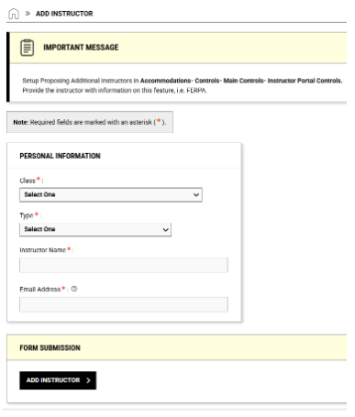
  - The system will use the results in the table below for the Export Data output. Please use the Refine Search section if you need to customize the search result.

ADD INSTRUCTOR
For sections assigned to the instructor, they can Add Additional Instructor to the Course or Replace All Instructors with the New Instructor. The system will email the proposed instructor for confirmation.

UPLOAD SYLLABUS
Instructors can upload their syllabi by:
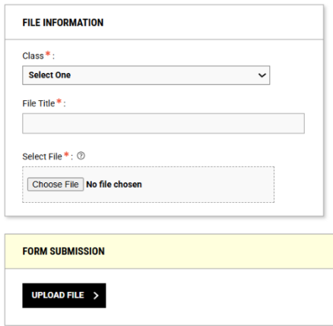
- Select the Upload Syllabus Link from the Home menu.
- Select the Class from the dropdown menu.
- Give the file a Title.
- Select the file for upload.
- Click Upload File.

Instructors can view syllabi they have previously uploaded and will be able to delete files they provided.
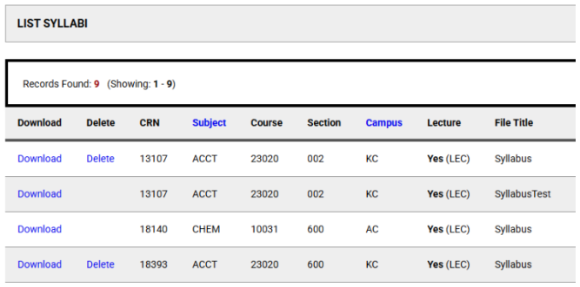

INSTRUCTOR PORTAL MODULES

ALTERNATE FORMATS
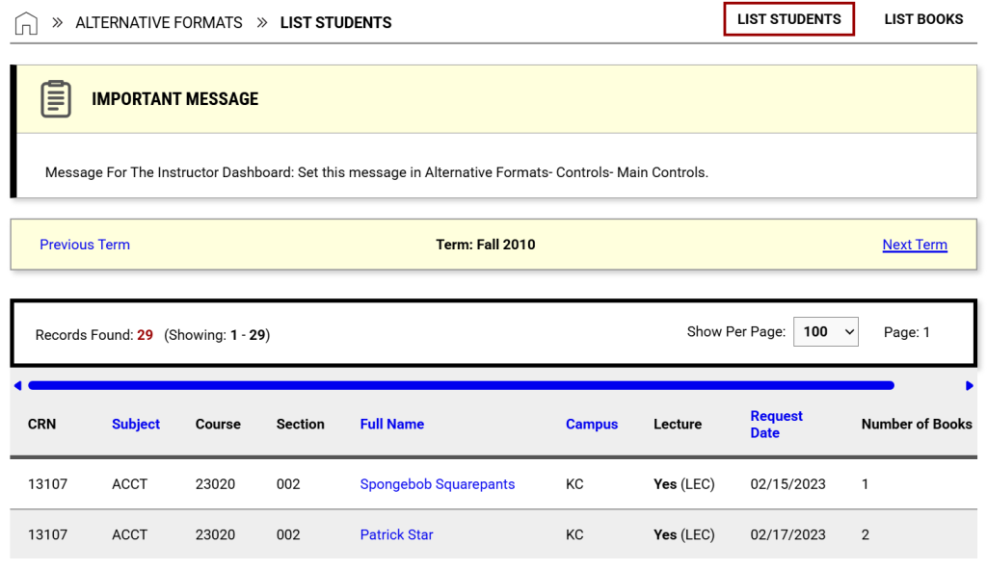Instructors can see which textbooks are being converted for accessibility. They view lists By Student or By Books and can navigate between terms.
List Students: Lists students with the request in a table by term.
List Books: Lists books and other materials individually.

COMMUNICATION ACCESS
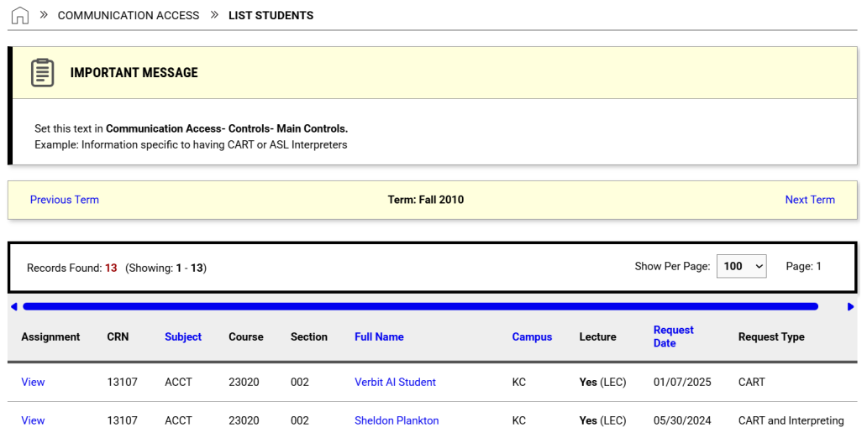
Instructors can see a list of requests for all of their courses by student with the service. Clicking View will display the assignment details.
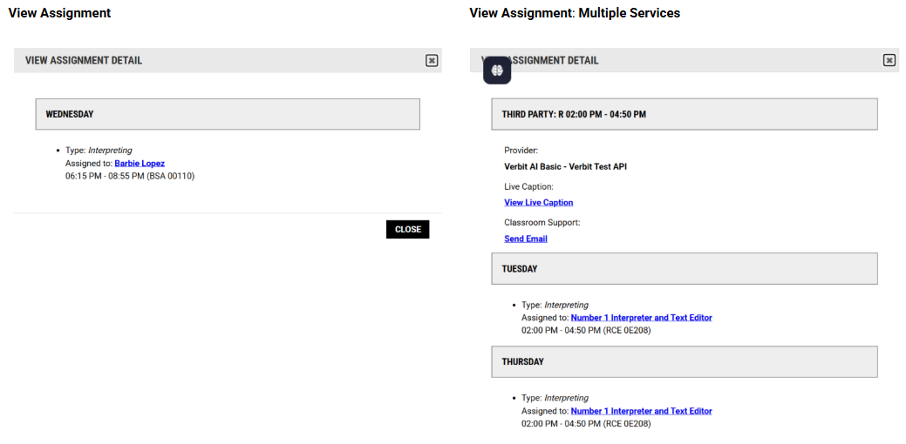
View Assignment | View Assignment: Multiple Services
Optional: View Transcripts If instructors are allowed to download transcripts, they will have an additional link at the top of the Communication Access module for Transcripts.
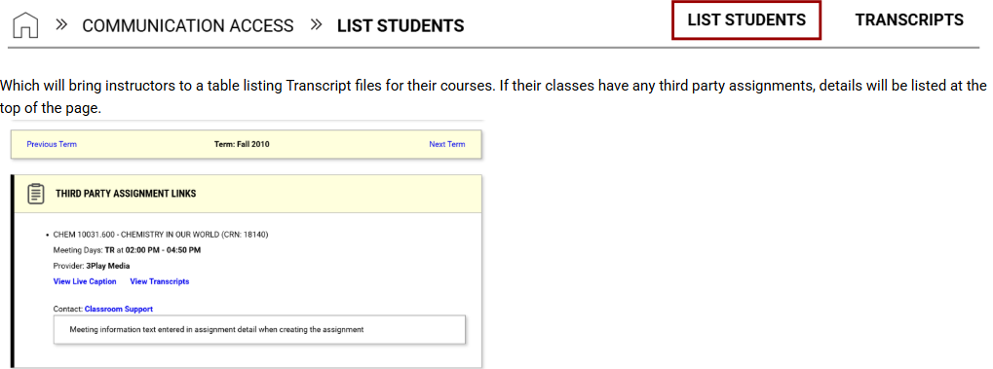
Which will bring instructors to a table listing Transcript files for their courses. If their classes have any third party assignments, details will be listed at the top of the page.

Flex Plans
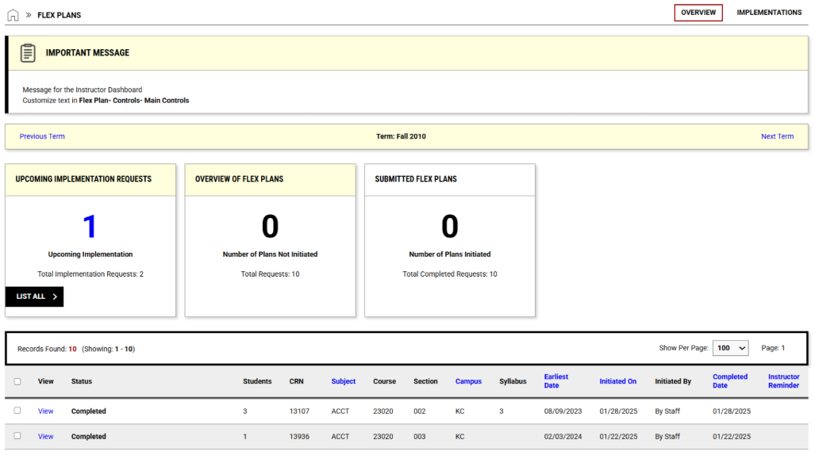

Initiating Flex Plans

Method 1: Complete Individually
- Navigate to Flex Plan.
- Click View for the plan you want to work on.
- Complete the List of Questions for your course. Note: Some schools prepopulate default answers which can be adjusted based on the essential requirements of the course.
- Upload a Syllabus for the course.
- Click Initiate and Request Review which will alert the DS office.

Method 2: Complete in Bulk
- Multiple courses can be completed in bulk by navigating to Flex Plan.
- In Step 1: Select Courses select the checkboxes for the requested plans to be completed (ex. all sections of Bio 100.)
- In Step 2: Select Available Options choose Start A New Plan from the dropdown list then click Specify Flex Plans for Multiple Courses.
- Complete the Question List. Prepopulated answers can be adjusted based on the essential functions of the course.
- Click Initiate and Request Review

Method 3: Copy Flex Plan
- Copy a completed plan by navigating to Flex Plan.
- In Step 1: Select Courses, choose which classes will be completed by this method.
- In Step 2: Select Available Options, choose the plan that you want to copy to the new courses from the dropdown list.
- You will have the option to make any adjustments needed in the Question List.
- Click Initiate and Request Review. Submitted Flex Plans

Submitted Flex Plans
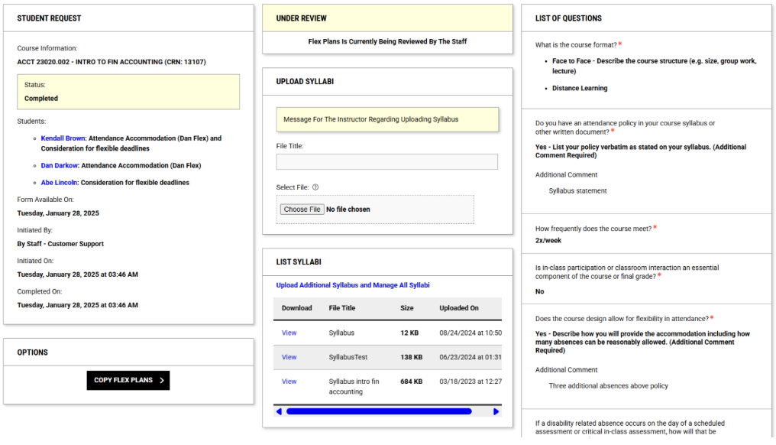

Optional: Implementation Requests
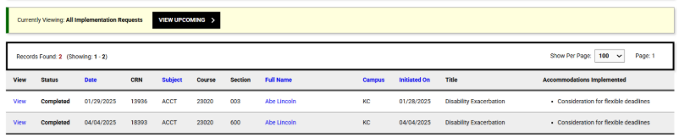

Notetaking Services
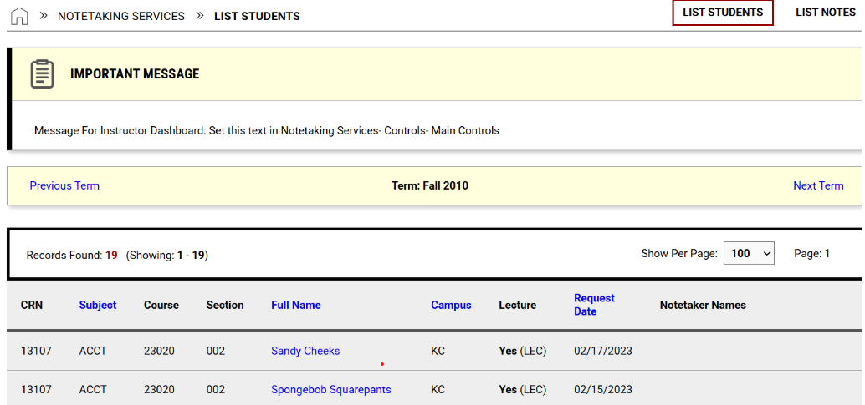
Instructors can view a list of students with Notetaking Services in their courses.

List Notes
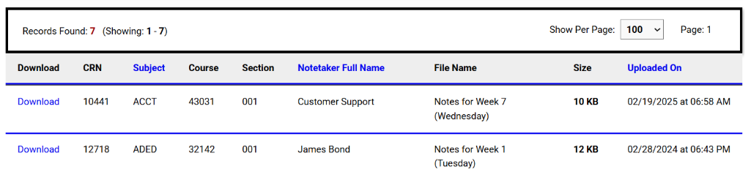
Instructors can download and view notes uploaded to AIM for their classes.

Testing Accommodations
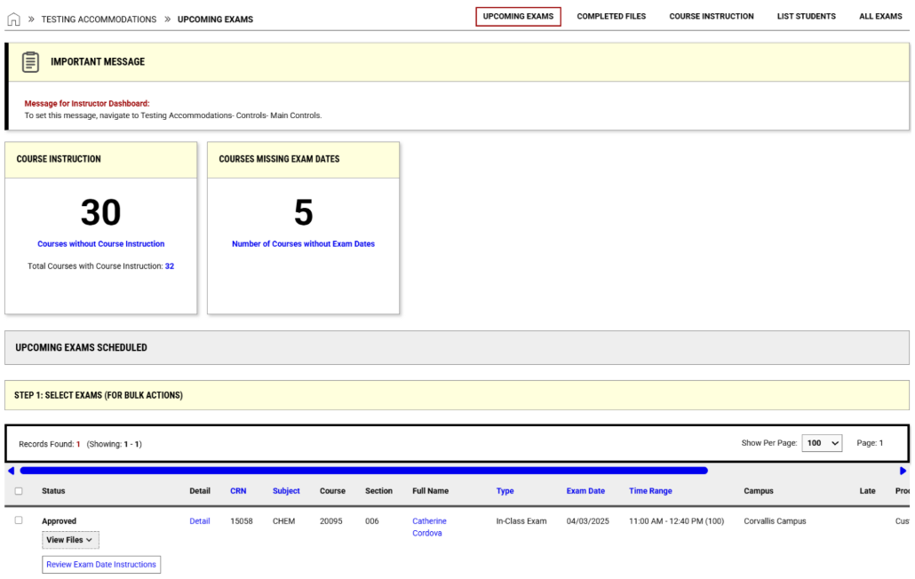
For schools with access to the Instructor Portal after instructors complete the course instruction form, the next step is submitting Exam Dates. Instructors should:
- Access the testing module within the instructor portal
- Select the link to the “Number of Courses without Exam Dates”
- For the class the instructor wishes to add exam dates, select “View/Modify Course Instruction”
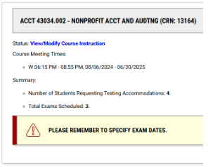
- Select “List Exam Dates” from the top menu
- Add “Exam Details”
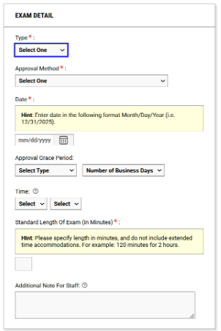

Approval Grace Period
- Allowance period before or after the scheduled exam date that the exam can be scheduled for, helpful for courses that allow students to choose a date within a window. This is not shared with the students. (Minimum of 1 day must be selected.)
- Upload Exam file
- Select “Save Exam Date”
- Dates will list with the grace period in parenthesis
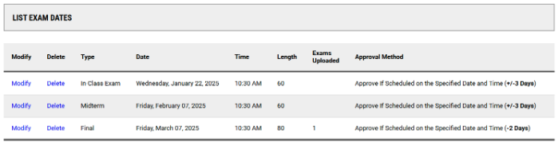

Bulk Exam Upload
- Instructors can choose from a list of upcoming exams to apply one file to.
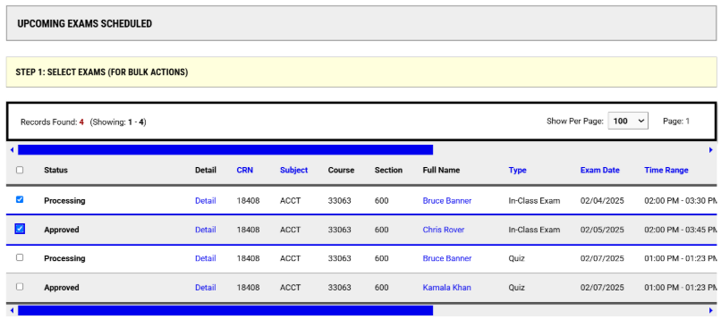
  - In our example, the in class exam is being administered on two different days by the DS office, Bruce on 2/4 and Chris on 2/5, the instructor selected both to have the same exam file.
- Once you have selected the exams that need a file, scroll down and enter the file title and select the file from your computer to upload and then press the “Upload File” button.
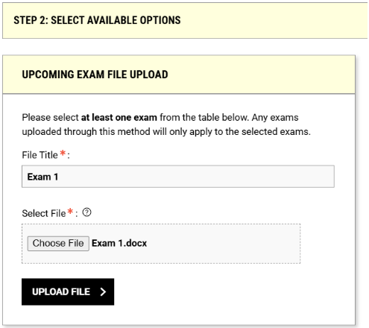
- Once uploaded, the list will identify which exams have a file associated. 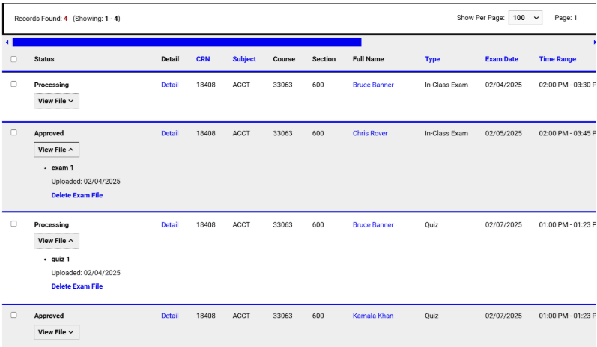
Instructors can:
- Submit a Testing Contract or indicate they will proctor exams
- View a list of scheduled exam requests
- See request approval status from disability services
- Upload exams directly
Steps
- Click Alternative Testing
- To change the term, use the Next Term link (top right)
- Indicate whether they will proctor their own exams or submit a Testing Contract for disability services
- View exam requests and their statuses
- Upload exams directly

Video Captioning Instructor view
Instructors will have a few options for interacting with the Video Captioning module. If you decide to allow instructors to submit requests, they will be able to input video information into AIM and view their previous video requests for their specific class(es). A link to the Captioning Video Request Form will be included in the request letter.
They can also log into AIM to view the details and progress of their requests and access the link to the captioned videos.
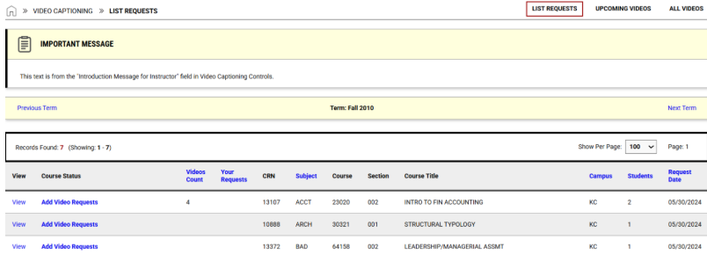

List video requests
Shows the amount of videos per each class that has a captioning request
- View: This link will take the instructor to view all videos processed for this course
- Course status: Status will show how many videos will be coming up on the schedule. The “Add video requests” link will take them to the page to input more video information
- Video count: How many Video Assignments total are being processed for this course
- Your requests: How many video requests have been submitted, but not yet transferred over as an Assignment
- CRN
- Subject
- Course
- Section
- Course title
- Campus
- Students: Amount of students with a captioning request in this class
- Request date
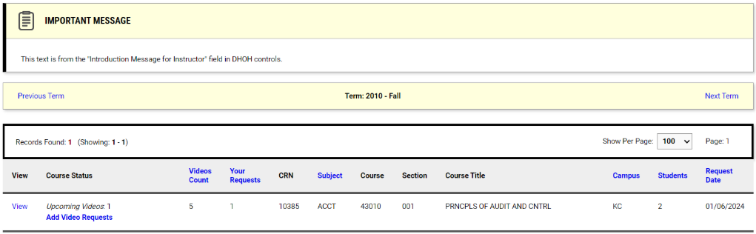

Upcoming videos
This page will show the individual videos that will be coming up according to the show date
- Link: Show video button will take the instructor to the captioned video url that was input into the Video Assignment Details
- CRN
- Subject
- Course
- Section
- Video title
- Show date
- Type
- Updated on
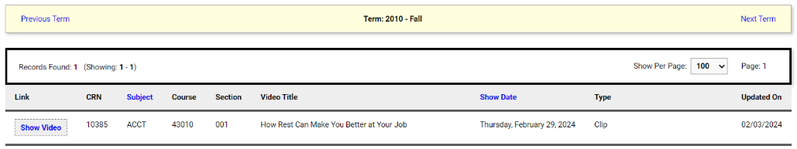

All videos
This page will show all of the videos being processed for their courses
- Link: Show video button will take the instructor to the captioned video url that was input into the Video Assignment Details
- CRN
- Subject
- Course
- Section
- Video title
- Show date
- Type Updated on
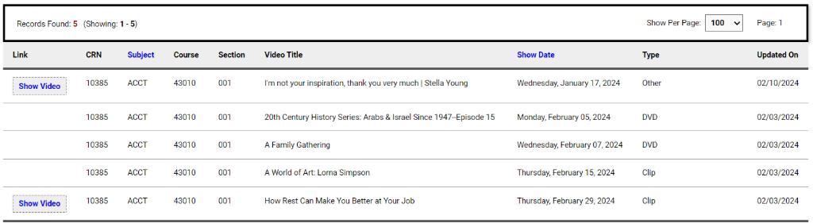

Add Videos from Request letter
When an instructor selects the link to the Video Captioning form in the email they received, they will be taken to a page where they can input video information for their class. This does not require them to log-in, so to view more information related to the progress of their requests – they will need to log-in to view their classes through the Instructor Log-in option.
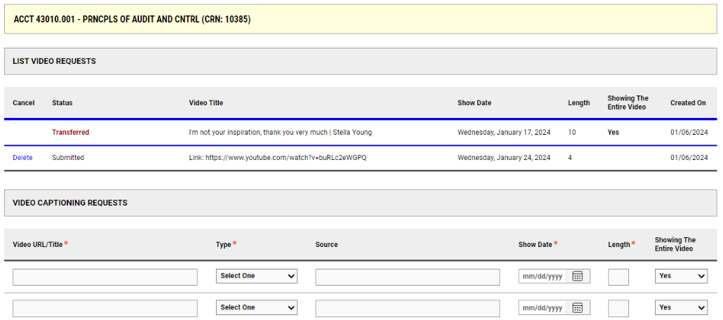
List Video Requests: This list will show the video title, the show date and whether or not their request has been transferred over to the assignments page.
Video Captioning Requests Form: Instructors are required to input the video title, type, show date and length. If the video is online, they can provide a source link. They also can indicate if they are showing the full video or not.
NSTRUCTOR PORTAL FAQS
IS THERE AN EASY WAY TO DIRECT INSTRUCTORS TO A SPECIFIC MODULE IN THE INSTRUCTOR PORTAL?
Answer: Yes! You can use the following URL to navigate directly to different modules in the instructor portal. https://servername.accessiblelearning.com/SCHOOLID/instructor/Default.aspx?R=[TAG] Possible tags:
- Alternative Testing: ATS
  - ATS-Completed: to view completed exams
  - ATS-Instruction: to view courses without instruction specified
- Alternative Formats: ALF
- Notetaking Services NTK
- Communication Access: DHO
- Video Captioning: VID
- Flex Plan: FLX
- Term Code: to view accommodation requests for specific term

