

Disability Support Programs & Services Faculty Handbook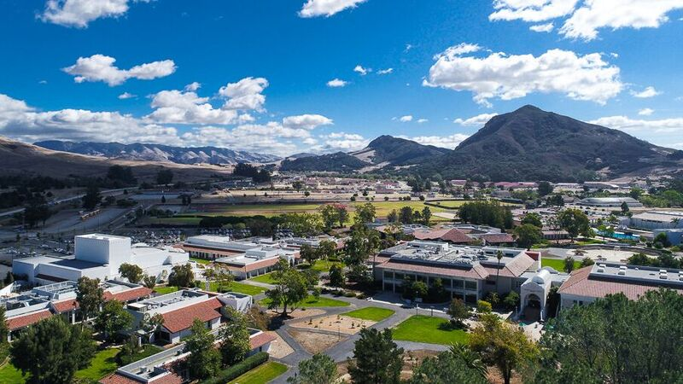

DSPS Contact Information

Director: Stephanie Schlatter (805) 592-9417 stephanie_schlatter@cuesta.edu

Front Desk: Answers general questions and directs inquiries to appropriate staff
- Alysha Nye- San Luis Obispo Campus- Program Assistant
  - alysha_nye@cuesta.edu
  - (805)592-3148
- Judy Ritmiller- Program Assistant
  - judy_ritmil@cuesta.edu
  - (805)592-9615

Specialists: Professional DSPS guidance for students and faculty, student academic accommodation plans, and learning disability testing
- Kathy Peters- (Fully Remote) SLO & NCC
  - kpeters@cuesta.edu
  - (805)592-9483

Support Services: Provides DSPS support services including alternative testing, note taking, assistive technology, adaptive furniture, ASL interpreters, and alternative media/books
- Devina Knott - Testing Coordinator
  - Devina Knott@cuesta.edu
  - alttest@cuesta.edu
  - (805)592-9485
- Juan Pablo Vega Quinones – Alternative Media Facilitator
  - Juan_vegaquinones@cuesta.edu
  - (805)592-9248
- Dannielle Vogel- Accommodation Assistant
  - danniellevogel@cuesta.edu
  - (805)592-9565
- Jo Malizia- ASL Interpreter
  - joann_malizia@cuesta.edu
  - (805)592-9217
- Christine Groff -ASL Interpreter
  - christine_groff@cuesta.edu
  - (805)592-9349
- Michelle Bach-Peters- Department Assistant
  - michelle_bachpeters@cuesta.edu
  - (805)592-9348

Academic Counseling: Academic Planning and counseling for DSPS students
- Jamie Bettencourt
  - Jeremy_bettencourt@cuesta.edu
  - (805)592-9543

Locations: SLO Campus - Bldg 3300 Student Success Center NC Campus - Bldg N3100 Rm 3121

TABLE OF CONTENTS

TITLE PAGE

- Introduction & Governing ………………………………………………………. 3

- What do you know about DSPS? …………………………………………………5

- Tips for Faculty …………………………………………………………………. 7

- Accommodations and Services ………………………………………………… 11

- Disability Categories Defined …………………………………………………..14

- DSPS Process …………………………………………………………………... 19

- DSPS Note Taking Process…………………………………………………..... 20

- Testing Accommodation Process ………………………………………………. 21

- Tips for Working with Students with Disabilities ……………………………… 23


Introduction and Laws Governing Community Colleges
Cuesta College is committed to ensuring that students with disabilities receive appropriate accommodations in their instructional activities as mandated by federal and state law and by College/District policy while maintaining academic integrity. DSPS at Cuesta College serves more than 800 students each year. Cuesta College DSPS endeavors to make reasonable accommodations in its policies, practices, and facilities, to ensure equal opportunity for eligible persons with disabilities to participate in all programs and activities. Whenever a special accommodation or auxiliary aid is necessary in order to assure access to and full participation by students with disabilities in college programs or services, the department or service responsible for the program or service to which the individual requires access, will work with DSPS to ensure that reasonable accommodations are made.

Rehabilitation Act of 1973
Section 504 specifically states: “no otherwise qualified individual with handicaps in the United States, as defined in section 7(8), shall, solely by reason of the handicap, be excluded from the participation in, be denied the benefits of, or be subjected to discrimination under any program or activity receiving Federal financial assistance or under any program or activity conducted by any Executive agency or by the United States Postal Service” (The Rehabilitation Act of 1973).
The effect of Section 504 on post-secondary institutions is summed up by the concept of program accessibility to students with disabilities. “accessibility includes the elimination of policy barriers, the provision of auxiliary aids such as readers and interpreters, and the provision of equal educational services and programs to disabled and non-disabled students, as well as the traditional physical access to the campus” (Johns, CAPED, Vol. 1 (No.1), p.7). Furthermore 504 states: “in its course examinations or other procedures for evaluating students’ academic achievements, institutions shall provide such methods for evaluating the achievements of students who have a disability that impairs sensory, manual or speaking skills as will best ensure that the result of the evaluation represent the students’ achievement in the course, rather than a students impaired skills (except where such skills are the factors being measured)” (Section 504, Subpart E, 104.44c). An instructor in some cases may be required to modify test arrangements for students with disabilities. For example, a student with a learning disability may be given the option of completing an oral exam rather than an essay type exam. The modified format of a standardized exam will depend upon the nature of a student’s disability and the best way to measure the student’s knowledge of the subject.
The Rehabilitation Act of 1973 defines handicapped individuals covered in Title 5 as “any person who (i) has a physical or mental impairment which substantially limits one or more major life activities (i.e., caring for oneself, performing manual tasks, walking, seeing, hearing, speaking, breathing, learning and working), (ii) has a record of such impairment.

AMERICANS WITH DISABILITIES ACT (ADA)

In 1990 the ADA became law, extending universal civil rights protections to individuals with disabilities for the first time. The ADA was modeled on the Section 504 regulations and the federal case law that interpreted them. The ADA extended the protection for individuals with disabilities beyond federally funded institutions.
The Americans with Disabilities Act has had a dramatic impact upon program and physical accessibility for students with disabilities. Section 36.309 of ADA (Title III) specifically states that “Any such authority that is covered by 504, or by Title II, because it is a function of a State or local government, must make all of its programs accessible to persons with disabilities, which includes physical access as well as modifications in the way the test is administered, e.g., extended time, written instructions, or assistance of a reader”. Furthermore, “a public entity offering an examination must ensure that modifications of policies, practices, or procedures or the provision of auxiliary adds, and services furnish the individual with a disability an equal opportunity to demonstrate his or her knowledge or ability…”
The ADA uses the same definition of an individual with disabilities as Section 504, and specifies three protected categories:
- Individuals who have a physical or mental impairment that substantially limits one or more major life activities;
- Individuals who have a record of a physical or mental impairment that substantially limits one or more major life activities; and
- Individuals who are regarded as having such an impairment.
Both the Americans with Disabilities Act and Section 504 regulations state that the college shall provide academic accommodations unless:
- The college can demonstrate that the accommodations are not necessary to ensure nondiscriminatory participation by a handicapped student, or
- The college can demonstrate that the academic requirement for which an adjustment is requested is “essential to the program of instruction being pursued by (the) student”.
Legal references: Section 504 of the Rehabilitation Act of 1973, 2990 Americans with Disabilities Act, Title II.

What do you know about DSPS?
- I have the right to tell a student with a disability that he/she cannot use a recorder in my class
  - False – Federal and state mandates require that accommodations written for students with verified disabilities to be followed (Americans with Disabilities Act, Section 504 of the Code of Federal Regulations). If the student has a verified disability and it is determined that this is a necessary accommodation to address that student’s specific educational limitation, the student may record the class.

- Giving extra time on tests gives students with disabilities an unfair advantage.
  - False – Accommodations are legally mandated and are intended to provide students with documented disabilities an opportunity to be evaluated on ability, not disability. Testing accommodations create an environment that allows students to appropriately demonstrate their mastery of the material. Disabilities may include learning disabilities, visual impairments, motor disabilities, head injuries, attentional or psychological disabilities. For some, the accommodation itself requires more time to adaptive equipment such as text enlarger, an audio exam or an adaptive keyboard. Testing accommodations ensures that the exam grades most fairly represent the student’s knowledge of the course material with minimal interference from their disability.

- I have a student who needs a note taker, should I announce this to the class?
  - This is partially true. If a student has an approved accommodation of a note taker DSPS will outreach the instructor asking to announce that a note taker is needed. Please do not mention the student’s name when making the announcement; this is protected by Federal Family Educational Privacy Act of 1974.

- I can deny a student’s accommodation if I think it isn’t fair without consulting with DSPS
  - False – If you feel that an accommodation fundamentally alters the course you can contact the Director of DSPS who can work with you to determine if the accommodation fundamentally alters the course.

- It is the responsibility of the student with the disability to provide documentation of his/her disability to the college
  - True. It is the student’s responsibility to self-disclose and provide documentation to the college, however, if you believe that a student has a disability, have a private conversation with the student about your observations of his or her academic performance. Refer the student to all support services available including our DSPS office.

- If you receive an accommodation letter you should ask the student what their disability is
  - False – you should not ask a student what their specific disability is. They have provided appropriate documentation to the DSPS office and they don’t need to disclose their disability unless they choose to do so.

- If there is a dog in your classroom or you see a dog on campus you should ask if he/she is a service animal
  - False- Public Safety is the only entity that can ask, but if a dog’s behavior is concerning please contact Public Safety directly and they can respond appropriately.

- You should not pet service dogs while they are working
  - True – While a service dog is working, they have a lot on their mind, and petting them can be very distracting. Even when a dog is “on a break”, do not touch without permission.
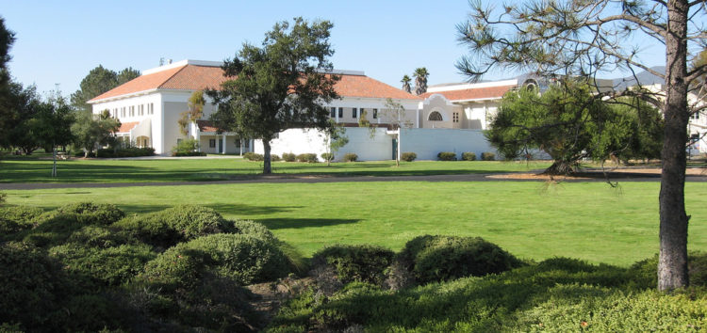

Faculty FAQ
- Is there a Faculty resources space?
Yes, please visit the Faculty Room: (https://cuesta.instructure.com/courses/108).
The faculty room is a space for faculty and administrators at Postsecondary institutions about how to create classroom environments and academic activities that maximize the learning of all students, including those with disabilities.

- What is an Academic Accommodation Plan?
To receive services from DSPS, students submit appropriate documentation to DSPS and meet with a Disability Specialist who will determine appropriate accommodations based on the documentation submitted.

- Are students required to divulge the nature of their disability?
No, students are not required to tell you the nature of their disability or to provide copies of their disability documentation. DSPS is charged with documenting disabilities and recommending reasonable accommodations.

- Why do students use accommodations sometimes and not at other times?
Students are determined to be eligible to request accommodations under the umbrella of the American’s with Disability Act (ADA). Students have the responsibility to identify themselves to their various instructors and to request accommodations. A student may choose to use the accommodation at one time but not at another. For example, a student may take the first test without the accommodation to see how they do with the time allowed and for future exams may request to use their testing accommodation. Because the student did not request an accommodation in one instance does not negate their right to ask for it for another.

- What are some reasons students do not disclose to instructors right away?
Disclosure is very difficult for many students. There are several reasons why students may not disclose their disability and need for accommodations. Some students may try college without using their accommodations first. Some students have disabilities with symptoms that are not always present so they may not request accommodations until those symptoms exacerbate. Students often try to avoid unnecessary disclosure. Many of our students are new to personally managing their disability; in K-12 students with disabilities are accommodated in a very different way and through a process that is managed for them. We view this as a learning process and DSPS works with students to develop skills in managing and advocating for themselves.

- What is Universal Design?
For information on Universal Design please visit: (Universal Design for Learning)
Universal Design can provide a starting point for developing a framework of instruction that can maximize the learning of all students. You can apply this body of knowledge to create courses where lectures, discussions, visual aids, videos, printed materials, labs and fieldwork are accessible to ALL students.
- Should I maintain confidentiality?
Student Academic Accommodation Plans are confidential. It is important to make sure that no other student and/or staff can overhear conversations you are having with a student about their disability or accommodations. Students are not obligated to disclose their diagnosis, but you can ask how their disability impacts class participation and meeting course expectations.

- What do I do if I suspect a student has a disability?
Do not tell a student you think he/she has a disability! Approach the student as you would any other student having difficulty in the class. Inquire about what might be impacting the students’ progress in the class. A student with a disability will likely disclose at this time if the difficulties are disability-related. Refer the student to DSPS if they disclose a disability or indicate they suspect a disability. If neither of these scenarios occurs, we recommend providing the student with a list of campus resources, including the DSPS.

- How do I address questions from other students in your class about why a student is receiving an accommodation?
Even if a disability is obvious (e.g. physical, blindness) instructors need to keep that information confidential and can only share on a need to know basis with other faculty/staff. If you are questioned by students as to why a student is receiving ‘different’ treatment you can point out that many school issues are personal and at Cuesta our policy is to respect individual’s privacy.

- What are Reasonable Accommodations?
Reasonable accommodations are specific recommendations or strategies, technology or aids, which are needed to accommodation a disability without compromising the integrity of the program.
Reasonable Accommodations should:
- Mitigate the impact of the disability
- Level the playing field for students with disabilities
- Be reasonable in relation to the course
- Best ensure a student’s access to instructional material
- Best ensure a student’s ability to demonstrate competency of curriculum
Reasonable accommodations should not:
- Water down curricula or compromise academic integrity
- Fundamentally alter any essential elements of the curriculum or academic program
- Ensure that all students with disabilities are successful
- Consume extra personal time from the instructor to re-teach the student

- What does ‘attendance flexibility’ mean?
DSPS does not have a role in determining course attendance policies. As attendance may be integral to the pedagogic process, these policies are set by faculty at the departmental level. DSPS never advocates for students to miss class. However, some students experience recurrence of a chronic condition requiring bed rest and/or hospitalization. In most situations students are able to make up the incomplete work, but they may need extra time. Reasonable accommodations for such absences may include, but are not limited to, flexibility of class attendance policy, extension of time for assigned work and flexibility in making up missed assignments and tests. It is not a free ticket to not come to class and we never suggest that a student use it that way. It is intended to give instructors a heads up that a student may have a medical appointment or hospitalization that is unable to be change and as such, we recommend some flexibility. This is an accommodation that must be related directly to their disability and a specific issue. Students will be expected to assume responsibility for providing notification of absences and for making up missed assignments and work.

- How is extended time fair?
The Rehabilitation Act and the Americans with Disabilities Act (ADA) states: “the result of an examination should accurately reflect an individual’s aptitude or achievement level or whatever the test proports to measure, rather than reflecting on an individuals’ impaired sensory, manual, or speaking skills.” The courts have held repeatedly that a lengthening of the standard examination period is an appropriate accommodation for some students with disabilities.

- Can I deny an accommodation?
No. The only reason an accommodation can be denied is if that accommodation fundamentally alters the course or academic activity. If you are concerned this may be the case you can contact the Director of DSPS so we can collaborate in determining if this would be appropriate. Opinions about fairness, concerns about cheating or inconvenience of the instructor are not sufficient or legally defensible reasons to deny an accommodation.

- How do I manage Pop Quizzes?
Pop quizzes can be very challenging to provide testing accommodations; as some accommodations may be extended time, low distraction or they may need to use a software program that allows them to take the quiz (for example, a student with dyslexia may need to use a text to speech software program)....here are some ideas/strategies... and I encourage you to discuss these with the student directly and I am more than happy to talk through this more as well.
- Base course grade on an average of other tests/assignments and don't count the pop quizzes
- Use canvas for quizzes, assign quizzes to be taken at specific times and for specific length of time (and those with accommodations the time can be extended to meet the accommodation)
- Allow student to take quiz with class and stay to complete quiz after class (though during the discussion with the student make sure they are able to stay after class to complete it)
- Invite student to office hours and have student take quiz during that meeting time or schedule time for them to take it in DSPS
- Allow students to take quiz with class, stop when class stops and grade only on the portion completed

- When in Doubt – Ask
Reasonable accommodations are provided to individuals with disabilities in order to ensure they have equal access to participate in all programs and activities. Civil Rights laws protect individuals from discrimination but do not require special privileges or unreasonable accommodations. Accommodations should not fundamentally alter the nature of the academic task or activity; if you question the reasonableness of an accommodation request, please contact the Director of DSPS so that we may collaboratively assess the situation.

DSPS Services and Accommodations
The major objective of the Disabled Students Programs and Services office at Cuesta College is to ensure educational access for students with disabilities. DSPS concentrates its efforts on providing services that are not available elsewhere in the college. DSPS makes the following services available to qualified students at Cuesta College.

Alternate Media
All college publications and instruction materials can be made available to students with disabilities in an alternate media of their choice. For example, the DSPS Alternate Media Specialist can Braille almost all the instruction materials an instructor makes available to students. Contact Alternate Media Specialist SLO x9248.

Note Takers
A student may use the assistance of a note taker. A note taker can be a person hired through DSPS that is not a student in the class or can be a Peer Notetaker in the classroom. DSPS may contact the instructor to announce the need for a notetaker (please never disclose the DSPS student’s name that will use this accommodation).

Digital recorder or Smart Pens
Students using a smart pen or digital recorder are using it entirely for note-taking purposes. In general, it is a tool that allows students to independently navigate the learning environment without having to rely on a note-taker.

What if I have a policy against the recording of lectures?
Section 504 of the Rehabilitation Act of 1973 states: “A recipient to which this subpart applies may not impose upon handicapped students other rules, such as the prohibition of tape recorders in the classrooms of or guide dogs in campus buildings that have the effect of limiting the participation of handicapped students in the recipient's education program or activity.” Before a student can check out a smart pen or recording device, he/she is required to sign a Recorded Lecture Policy. By signing this document, each student agrees not to share the recorded lecture notes with anyone else without the instructor’s consent.

Assistive Technology
DSPS offers adaptive computer hardware and software technologies to students with disabilities to assist in the process of making Cuesta College computer labs accessible to students with disabilities. The available technology includes, but is not limited to, voice recognition technology, voice synthesizers, screen reading software, Braille printer, reaching machines, optical scanner, and electronic key guards.
Text to speech/audio – Through the use of software programs such as Kurzweil, Zoomtext, and jaws students will be able to auditorily hear the text read to them. Students will be provided with access and will be trained by DSPS on how to use these programs.

Alternative Testing
Test taking for some individuals with disabilities can present specific obstacles. Student needs vary greatly, depending on the disability and type of test. General strategies for accommodating students with disabilities in testing include, but are not limited to:
- Alternative, quiet testing locations and distraction-reduced rooms
- Alternative test formats
- Extended test-taking time
- Provision of a reader or a scribe
- Use of a computer to complete test, use of a calculator.
DSPS Testing Center will work collaboratively with instructors to provide these services.

Architectural Barrier Removal
There is an ongoing process on the campuses for evaluating architectural barriers and recommending changes. The goal of significantly improving campus accessibility is a top priority for the district. If you notice any areas you would like to be brought to our attention please contact us at x3148.

Counseling
DSPS provides academic counseling, educational planning, and career counseling. DSPS coordinates necessary support services and acts as a resource to help students obtain appropriate services beyond those provided at Cuesta College.

Interpreters for Deaf & Hard of Hearing
Interpreters hired by DSPS are professionals who provide sign language interpretation in the classroom to students with severe to profound hearing loss.

Learning Disability Assessment
Individualized assessment to determine eligibility for learning disabilities services is available at Cuesta College. Students are referred by instructors, rehabilitation counselors, and/or by self.

Priority Registration
It is often important that students with disabilities enroll in specific sections of a course in order to appropriately access the college programming. This may be necessary for students to coordinate interpreter schedules, to participate in DSPS curriculum, or for mobility reasons. In addition, the actual process of registration can be especially difficult and stressful for many students with disabilities. It is for this reason that DSPS offers priority registration to qualified students.
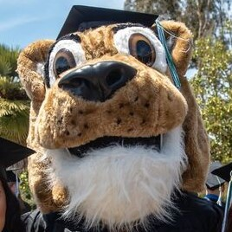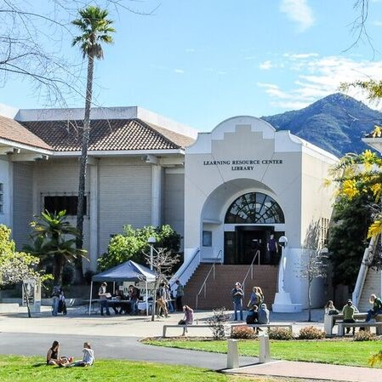

Disability Categories Defined
Title 5 of the California Code of Regulations defines the following disabilities for California Community College purposes.

ATTENTION DEFICIT HYPERACTIVITY DISORDER (ADHD)
Definition: Attention deficit disorder (ADD) is a neurobiological disorder. Malfunctions in brain chemistry result in inattention, impulsiveness or hyperactivity. Symptoms appear in childhood, are chronic in nature and not attributable to other physical, mental, or emotional causes.
Educational Limitations: ADD results in limitations in completing tasks, controlling impulsivity, or sustaining attention.

BLIND and LOW VISION
Definition: Blindness is often thought to be complete loss of vision with no remaining perception of light. However, this ultimate form of blindness is rare. Far more students have a permanent loss of some, but not all, of their eyesight. Blindness can be either congenital (occurring before or at birth) or is acquired as a result of trauma or a medical disorder. The severity of vision loss varies widely. The definition of legally blind is 20/200 vision with best correction. The most prevalent eye diseases are age-related macular degeneration, cataracts, diabetic retinopathy, retinitis pigmentosa, and glaucoma. Other vision impairments may be the result of night or color blindness, myopia (nearsightedness), astigmatism (irregular curvature of the cornea), hyperopia (farsightedness), and presbyopia where the eye lens becomes elastic.
Educational Limitations: Students who are blind or low vision will have limitations in reading, viewing classroom materials, boards, overheads, videos and other visual presentations. Getting around the campus will be a limitation as well as locating places or materials in labs and classrooms. In addition, visual perceptual problems such as discriminating figure or ground, sequencing, or reading similarly shaped letters or words may preclude comprehension of printed test materials. Students with low vision vary greatly in their ability to use vision. They may be limited in sharpness of vision or ability to see distances, or the student may have reduced central or peripheral vision. If the condition fluctuates, a student may have varying degrees of visual ability from day to day.

DEAF and HARD of HEARING (DHH)
Definition: Deafness refers to a profound hearing loss of 90 decibels or greater. Hard of Hearing refers to those students who have some residual hearing. Hearing loss may be conductive when there is a disruption of the transmission of sound through the outer and/or middle ear or sensorineural, which is due to sensory or nerve damage in the inner ear, auditory nerve, or auditory cortex of the brain. When the deafness is congenital (occurring before or at birth) or prelingual (before the age of about three when spoken language is normally acquired) the student will have significant communication impairments resulting from having a restricted exposure to language and social frame of reference when learning to speak, write, or lip-read.
Educational Limitations: The most significant limitation is that hearing loss cuts students off from the usual means of acquiring and transmitting spoken language. Deaf students cannot engage in spoken conversation, listen to information or enjoy the radio, television, movies, music, or video games. Limitations also include appreciating social nuance, jokes, and gossip exchanged by hearing people. Deafness limits hearing in various ways. Many deaf students are unable to perceive sounds, including speech, in a way for it to have meaning for ordinary purposes. Many other students are hearing impaired by background noise, cross talk and certain sound frequencies that limits accurate transmission of information. Deaf and Hard of Hearing students often are limited in mastering English grammatical structure despite intelligence and effort. Lip reading, while helpful, is only 30% to 40% effective and is very tiring.

OTHER HEALTH CONDITIONS and DISABILITIES
Definition: Some chronic health impairments are visible disabilities, but many are invisible illnesses or medical conditions. In some cases the degree of impairment will vary from one day to the next because of the nature of the medical condition, the medication used, or the therapy required. When illnesses do not follow a set course, are progressive, or involve chronic pain, the student may additionally experience depression, anxiety, or other emotions. Chronic Health impairments include AIDS, allergies, back disorders, burns, cancer, Crohn's disease, diabetes, fibromyalgia, heart disease, hemophilia, lupus, multiple sclerosis, muscular dystrophy, renal-kidney disease, respiratory disorders, seizure disorders, sickle cell anemia, Tourette's syndrome. Side effects of medication may include fatigue, memory loss, shortened attention span, loss of concentration, or drowsiness.
Educational Limitations: Medical complications result in a variety of limitations for these students including regular class attendance. In addition, attendance at particular times of day may be a limitation due to treatments or hospitalizations. Side effects of medication may limit classroom responses or taking tests in a timed situation. Some medical conditions may limit mobility, speech, vision, or muscle control. Students may be limited in their use of standard furniture or be limited in maintaining long class periods.

INTELLECTUAL DISABILITY (ID)
Definition: Title V of the California Education Code defines the developmentally delayed learner as a student who exhibits below average intellectual functioning and potential for measurable achievement in instructional and employment settings.
Educational Limitations: Students may have limitations with critical thinking, inferential reading, analysis or synthesis, and abstract reasoning.

ACQUIRED BRAIN INJURY (ABI)
Definition: Traumatic brain injuries result from either external events such as a blow to the head, or internal events, such as a tumor or stroke.
Educational Limitations: Limitations vary depending upon the type, location, and severity of the injury. The student is usually limited in cognitive functioning in the area of memory, concentration, speed of response, spatial reasoning, conceptualization, problem-solving, motor functioning or communication through reading, writing, speaking, or listening

LEARNING DISABILITY (LD)
Definition: Title V of the California Education Code defines learning disabilities as a persistent condition of presumed neurological dysfunction which may exist with other disabling conditions. This dysfunction continues despite instruction in standard classroom situations. Students with learning disabilities exhibit average to above average intelligence ability, severe processing deficits, severe aptitude-achievement discrepancies, and measured achievement in an instructional or employment setting.
Educational Limitations: Learning disabilities may result in limitations in the rate, accuracy, or efficiency of reading, writing, or math. A student with a learning disability does not lack aptitude or ability but is inhibited from demonstrating his or her true intelligence in at least one area of achievement (reading, writing, or math) due to the severe processing deficit. Time management, project organization or initiation, sustained attention, and social skills may be limited. Taking in information, retaining it, or expressing knowledge and understanding to others may be a challenge. The student will have uneven abilities and persistent deficits in auditory, visual, or memory functions.

PHYSICAL DISABILITY
Definition: There are a wide range of neuromuscular and orthopedic impairments that are congenital, the result of illness, or accident related. Mobility impairments range from slight difficulties with movement to paralysis. Such impairments may be caused by disorders such as arthritis or multiple sclerosis, or they can have congenital causes such as cerebral palsy or muscular dystrophy. They can also be the result of illness, accidents, strokes, or injury to the spinal cord. Some students have impairments in arm or hand movement that are the result of repetitive strain injury. These strain injuries can fluctuate in severity and are susceptible to aggravation from overuse.
Educational Limitations: Impairments can be painful and can limit mobility, strength, speed, endurance, or coordination. Mobility impairments cause difficulties with movement and fine-motor activity. In some conditions, limitations are constant; in others, flare-ups increase limitations intermittently. Some students have difficulty walking; others can stand but cannot walk. Fatigue may be a factor in limiting mobility; many students are able to walk but need to conserve energy by using a wheelchair occasionally. Limitations may include physical access to classrooms, offices, and rest rooms. Limitations may include use of standard height desks or tablet chairs. Some students are limited in their use of steps and may have limited choice in theater seating or may not be able to reach classrooms on the second floor if the elevator is not working. Sometimes upper extremity limitations, which involve the use of hands or arms, can impact the student's ability to reach and manipulate. Limitations may include fine motor tasks such as writing class notes, taking essays and tests, doing homework, completing tasks in science labs, or using computers.

MENTAL HEALTH
Definition: Psychological disabilities cover a wide range of conditions varying in symptoms and severity. In College the most commonly observed diagnoses are disorders of mood such as bipolar disorder and major depression. Other conditions are anxiety and panic disorders, obsessive-compulsive disorder, and schizophrenia. These disabilities are recognized to have a biological basis and many can be treated with appropriate psychotherapy and psychiatric medications
Educational Limitations: Most students with these psychological disabilities are limited with communication because they react to the increased stress of College by withdrawing. Psychological disabilities limit times of class choice because the student's functioning fluctuates throughout the day. Student's attendance may be limited because of relapses or hospitalizations.

AUTISM SPECTRUM
Definition: Autism Spectrum disorders are defined as neurodevelopmental disorders described as persistent deficits which limit the student’s ability to access the educational process. Symptoms must have been present in the early developmental period, and cause limitations in social, academic, occupational, or other important areas of current functioning.
Educational Limitations: Autism spectrum disorders are characterized by significant limitations and may include, but not be limited to any of the following:
- Limitations in social-emotional reciprocity (e.g. abnormal social approach; failure of normal back-and-forth conversation; reduced sharing of interests, emotions, or affect; failure to initiate or respond to social interactions);

- Limitations in nonverbal communicative behaviors used for social interactions (e.g. poorly integrated verbal and nonverbal communication; abnormalities in eye contact and body language; deficits in understanding and use of gestures; total lack of facial expressions and nonverbal communication);

- Limitations in developing, maintaining, and understanding relationships (e.g. difficulties adjusting behavior to suit various social contexts; difficulties in making friends; absence of interest in peers);

- Stereotyped or repetitive motor movements, use of objects, or speech (e.g. self-stimulation behaviors such as arm flapping, flipping objects, echolalia, idiosyncratic phrases);

- Insistence on sameness, inflexible adherence to routines, ritualized patterns, or verbal nonverbal behavior (e.g. Extreme distress at small changes, difficulties with transitions, rigid thinking patterns, greeting rituals, need to take same route every day, need to eat the same food every day); 2015 Implementing Guidelines for Title 5 Regulations 61

- Highly restricted, fixated interests that are abnormal in intensity or focus (e.g. Strong attachment to or preoccupation with unusual objects, excessively circumscribed or perseverative interest);

- Hyper- or hypo-reactivity to sensory input or unusual interests in sensory aspects of the environment (e.g., apparent in difference to pain/temperature, adverse response to specific sounds or textures, excessive smelling or touching of objects, visual fascination with lights

DSPS Application Process

DSPS Notetaking Process

- A DSPS student who has a verified disability and eligible for note taking accommodations requests a peer note taker for each class through their cuesta student portal (AIM).

- Instructor receives an email to their Cuesta email via AIM requesting assistance locating a student in class to share notes with a DSPS student. The email will provide a statement to read aloud during the next class meeting:
“If any student here takes good notes and is willing to share them with another student, please see me after class. Your help would be very much appreciated. For doing this, you will be eligible for priority registration next semester.”
Always maintain confidentiality of the DSPS student’s name unless they give prior permission to share it with the Peer Note taker.

- Once a student volunteers to share their notes, please either, refer them to DSPS, or take down their information and send an email to dspsinfo@cuesta.edu , so DSPS can follow up with the note taker. There are several ways the student can share his/her notes: carbon copy paper, a copier/scanner in the DSPS department, or email (if the student takes notes on his/her laptop).

If you have any questions, or if no one comes forward to share notes, please contact the DSPS office as soon as possible after the announcement is made.
Thank you for your assistance and cooperation!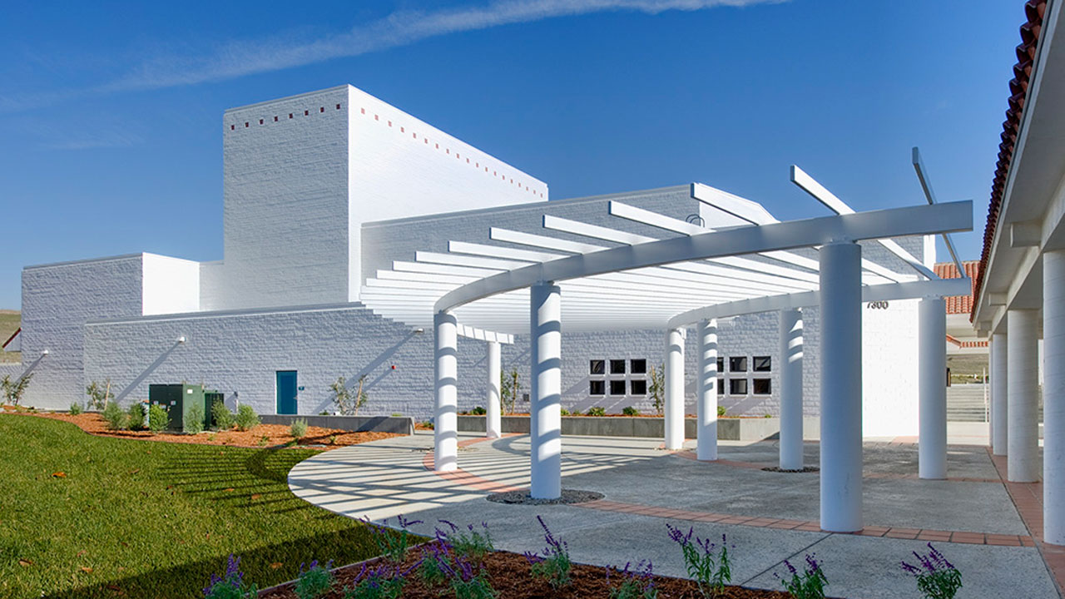

DSPS Testing Accommodation Process

Campus Test Proctoring:
For faculty holding in-person classes who are unable to meet a student's exam accommodations in class, DSPS is able to proctor tests in the testing center using an Alternative Testing Agreement completed online using the DSPS Faculty Portal (AIM).Please visit our Faculty How To page to learn more about managing Alternative Testing Accommodations and contact DSPS if you have any questions about testing accommodations.
- Review and discuss accommodations listed on your Faculty Notification Letter with the student in a private setting.
- If the student's needs are best met by your exams being proctored by DSPS, complete the Alternative Testing Agreement form online and be prepared to select alternate dates and times if your class schedule does not sufficiently overlap with those of the DSPS Testing Center.
- Upload your exams securely online and be prepared to answer questions from DSPS proctors leading up to and during the exam.
Please visit our Faculty How To page to learn more about managing Alternative Testing Accommodations and contact DSPS if you have any questions about testing accommodations.

Distance Learning Testing:
- The student will send the course instructor a faculty notification letter via the DSPS Online Portal (AIM). The testing accommodation (for example, extension of time allowed) is outlined in this letter and serves as authorization for the instructor to increase the test/quiz time.
- If the instructor needs assistance setting up the testing accommodation, please contact the DSPS testing services office.

Extending time in your Learning Management System (LMS)
Visit the module page in the Canvas Teacher Community for instructions on how to extend time in Canvas (Note: Extending times for multiple exams in Canvas at once is only possible using the "New Quizzes" feature). To extend time in McGraw Hill Connect visit the Knowledge Base Article on Assignment Extensions.

How to modify proctored online exams
Students using the Kurzweil text-to-speech browser extension may not be able to access exam content without modifying your remote proctoring solution (Honorlock Exam configuration).

Tips to Working with Students with Disabilities

General
- Make syllabus and textbook information available as soon as possible. Many students need alternate media and these formats can take time to create.
- Ask the students- while we encourage students to discuss their needs with their instructors this may not always be done. If you have questions about whether a student needs accommodation, the first person to ask is the student; but not in front of the class or other students.
- Respect the individual student’s privacy when discussing his/her performance, behavior or accommodations. Students may also decide not to use accommodations. This is also protected right for students with disabilities.
- Use terms such as “students with disabilities” rather than “disabled students” puts the emphasis on the person not the disability. Students are not required to provide their disability diagnosis to faculty members.
- Be flexible when you can.
- Without compromising instruction be flexible with absences and assignment due dates.
- Don’t be afraid to approach a person with a disability. Don’t worry about using words like ‘walk’ with a person in a wheelchair. As with anyone else, just treat them as you would like to be treated.
- Speak directly to the student, don’t consider a companion to be a conversation go-between. Even if the student has an interpreter present, speak directly to the student, not to the interpreter. Make eye contact with the student.
- Give your full attention – be considerate of the extra time it might take for a person with a disability to get things said or done. Don’t talk for the person who has difficulty speaking, but give help when needed. Keep your manner encouraging rather than correcting.
- Speak slowly and distinctly when talking to a person who is hard of hearing or has other difficulty understanding, speak slowly without exaggerating your lip movement. Stand in front of the person and use gestures to aid communication. Many students who are deaf or hard of hearing rely on being able to read your lips.
- Appreciate abilities – Student with disabilities, like those without disabilities, do some things well and others not as well. By focusing on what they can do, instead of what they can’t, you will help build confidence.

In Classroom
- Include a statement on the class syllabus inviting the student to discuss academic needs with you. For example: “Any student who feels s/he may need an accommodation based on the impact of a disability should contact me privately to discuss your specific needs. Please contact Disabled Student and Programs and Services (DSPS) to coordinate reasonable accommodations for students with documented disabilities
NCC: 805-592-6215 Office- N3121 LRC
SLO: 805-546-3148 Office – Building 3300 First Floor
- Use technology whenever possible.
- When possible allow students a variety of options to demonstrate mastery of core concepts, such as oral vs. written demonstrations, group projects, take home quizzes and exams, etc.).
- When participation appears to be difficult, grade on knowledge and application of course concepts instead.
- Be considerate of the extra time it might take for a person with a disability to get things said or done. Don’t talk for the person who has difficulty speaking.
- When lecturing, speak slowly, clearly, and begin with an outline of what is to be covered.
- Face students and read aloud any material written on the board or shown on the screen.
- Show only captioned videos and film clips.
- Make sure to give breaks in class to help students stay focused and engaged.
- Teach students memory tricks and acronyms as study aids.
- Restate key points several times. Try to present reviews and previews both visually and orally.
- Use color and graphics to emphasize key concepts and break down steps in solving problems.


